Francisco José Castro Fernández

Nukifx instalation and use manual

Download Tizen Sudio 3
Installing Tizen Studio 3
Installing NukiFX app 8
Installation 16
Screens, description and use. 19

Download Tizen Sudio
Copy and paste the following link into a browser to access the download page:
https://developer.tizen.org/ko/development/tizen-studio/download?langredirect=1
We can download the Tizen Studio 3.7 with IDE installer.

Installing Tizen Studio
To install Tizen Studio:
- Launch the Tizen Studio installer.
- Accept the software license.
The license contains important legal notices for using Tizen Studio. Read it fully, and click Accept only if you agree with the license statement:
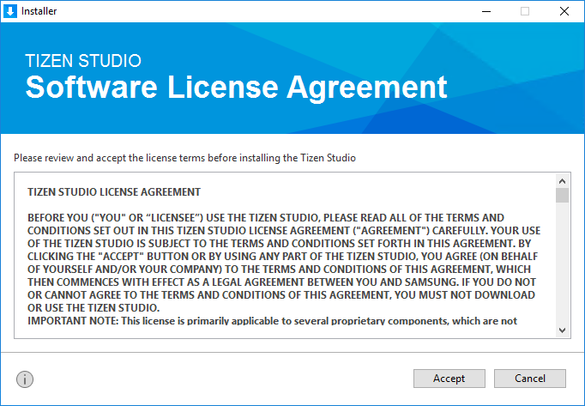
- Click the ... button and specify a new directory to set the SDK and data location. If the new directory is valid and shows no errors, click Install:
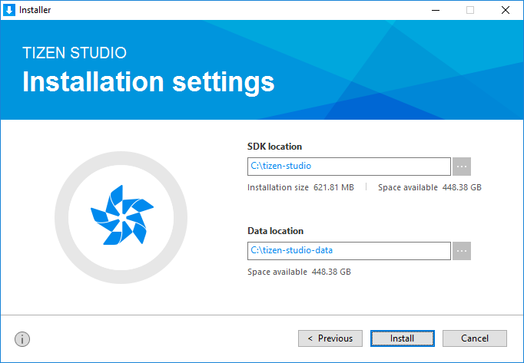
- Click Install to install the required packages and tools in the specified directory.
You can monitor the installation process or cancel the installation. The installation process is completed in a few minutes, unless you cancel it.
- Click Finish and close the installer:
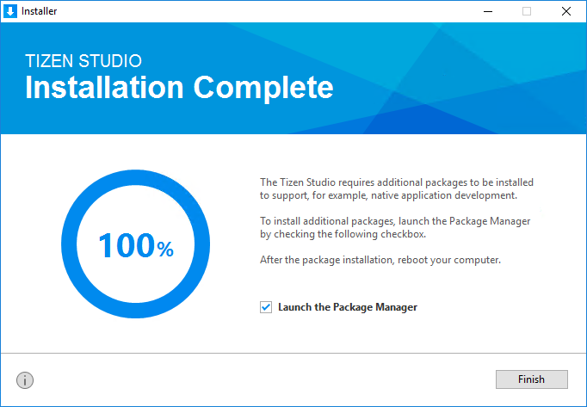
If you want to install additional platforms and tools, launch the Package Manager by checking the Launch the Package Manager check box and click Finish.

Package Manager
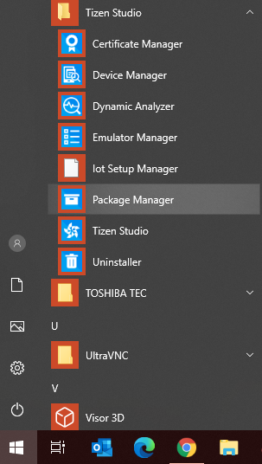
If we have left the option checked in the previous installation, the Package Manager will launch automatically, otherwise we can run it from the Tizen Studio installation folder:

In the Main SDK option, we must select the packages to install, we can start filtering by the packages for wereables:

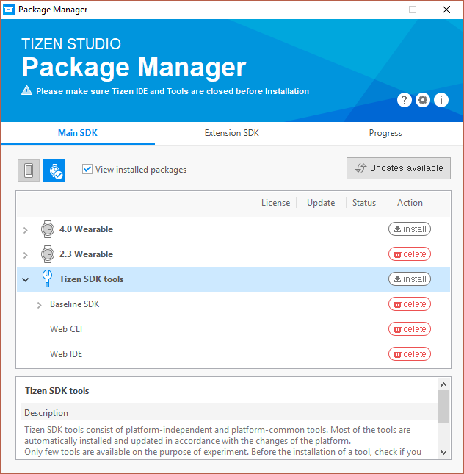
We must install the options for the Tizen 4.0 system, which is the minimum version that the application supports.

Installing NukiFX app

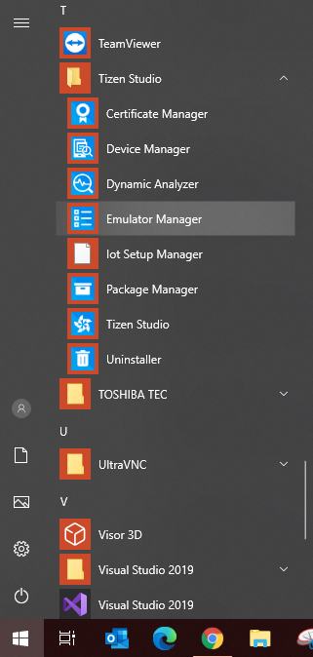
In the Tizen Studio installation folder, run the Emulator Manager.

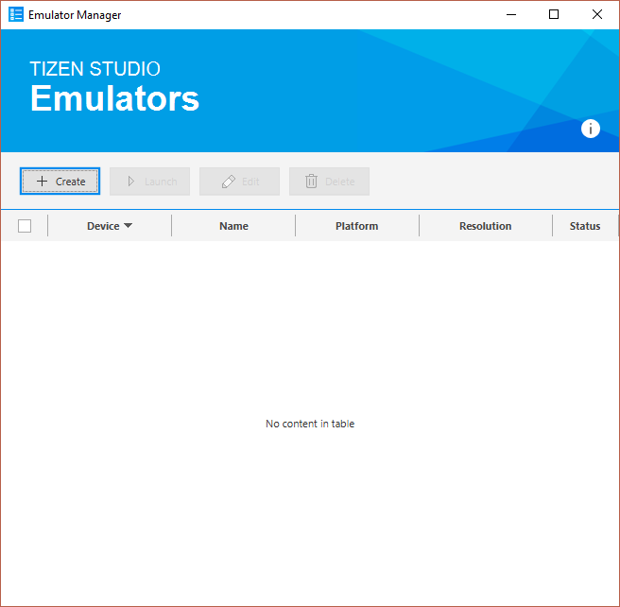
Once we have it on the screen, we must create an emulator.
For this we will press the Create button
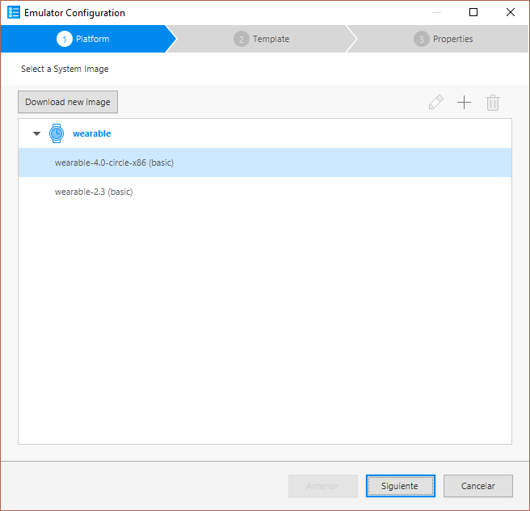
and, on the next screen, we will press the button to download a new image (if it doesn't exist yet):

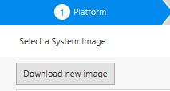

As we already have it installed, it does not appear, but we should select the option wereable 4.0.
In the example we can see how to select version 5.0:

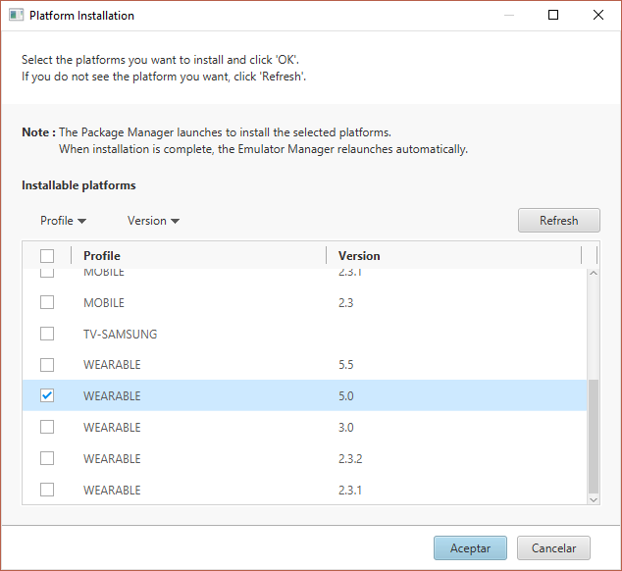
Once selected, we will click on the accept button.
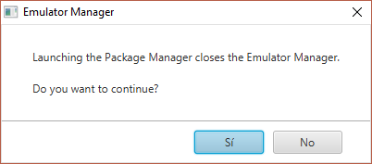
We will indicate that we do want to continue.
When the new image is installed, we will select it and click on next.
We go to the template option:
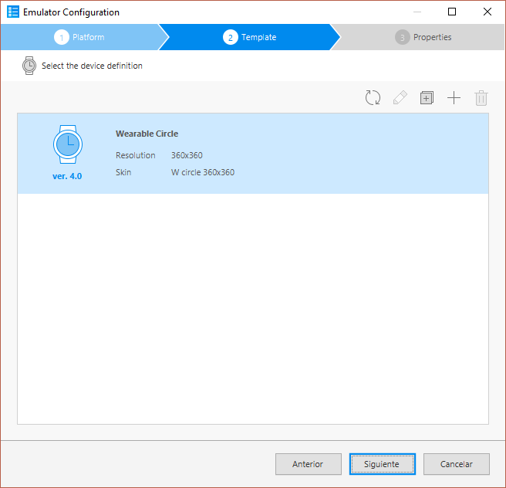

If it doesn't exist, we can add it with the + option:

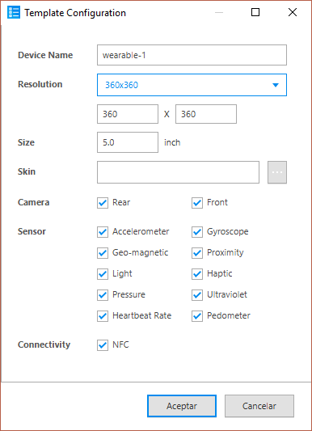

we select the option and click next.

Then we can see the properties window, but we don't need to change anything. We click on finish:
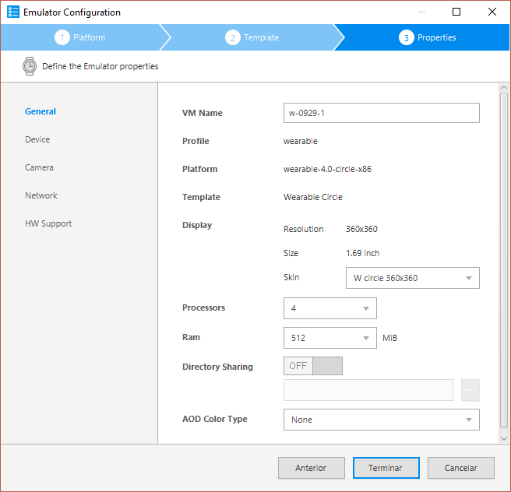

We will already have the emulator created:
We will click on the launch button.

You might get a message like this:
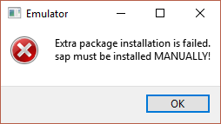
No problem, let's accept the message.
In a few seconds the watch emulator will appear:
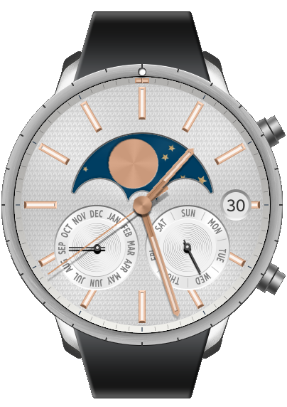

NukiFX

Installation
With the emulator running, we will drag the NukiFX-2.0.7.tpk file and drop it on it.
The following message will appear and we will select install:

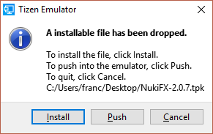

After a few seconds, it will install and we can test it.
To access it, we are going to install the applications widget on the clock. Using the mouse we will drag the clock screen from right to left, with which we will see the following image:

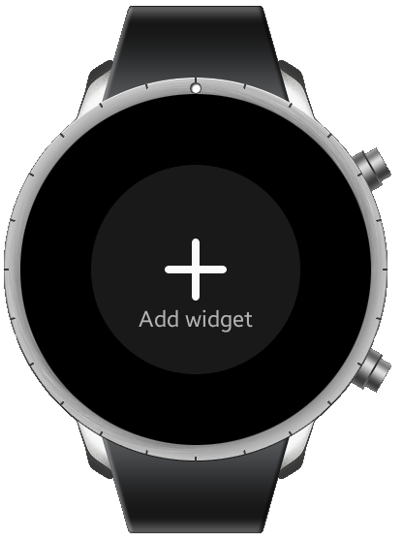
By clicking on the +, we will move with the mouse until we see the following image:

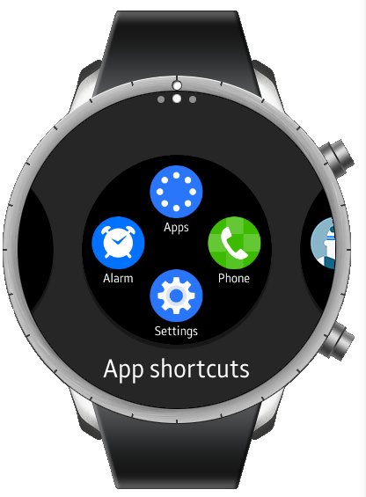
Now, we will click on it and it will be added to the options of our watch.
If we click on the Apps icon, we can see our installed application, and by clicking on it, run it.
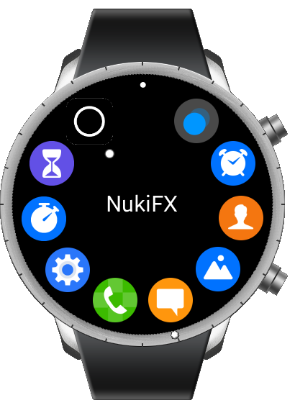

Screens, description and use.

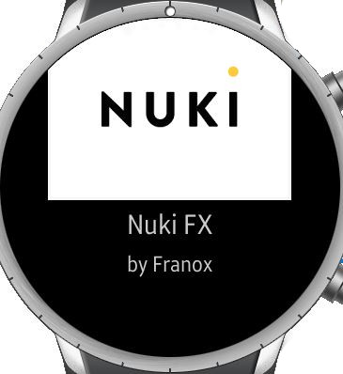 | 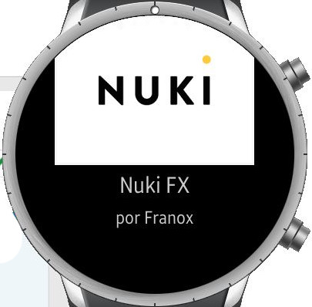 | Presentation screen
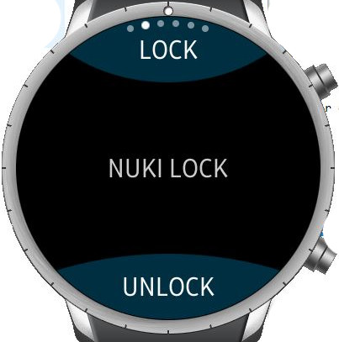 | 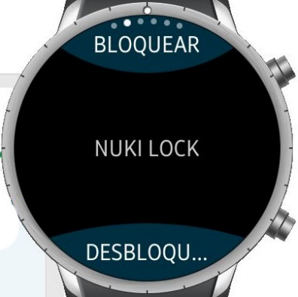 | Nuki Lock. By pressing each button, we can launch the order to open or close the device.
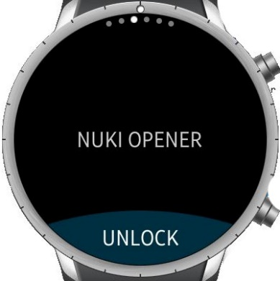 | 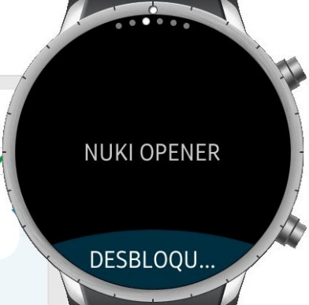 | Nuki Opener. By pressing the button, we can launch the order to open the device.
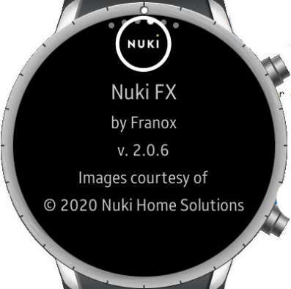 | 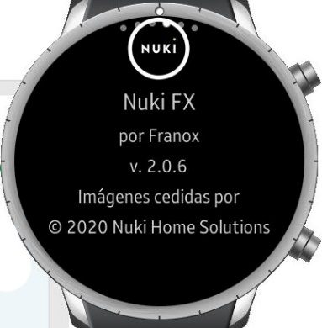 | Indicates the version of the application.
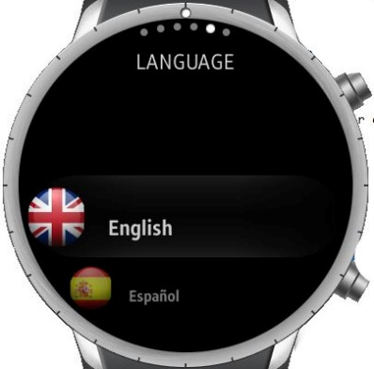 | 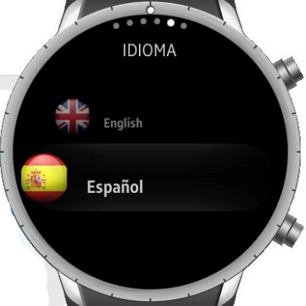 | Language selection. We can choose between English or Spanish. After the selection we must restart the application.
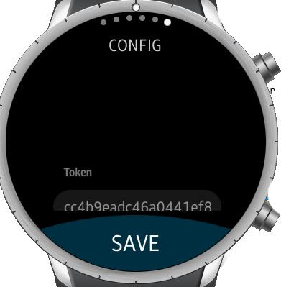 | 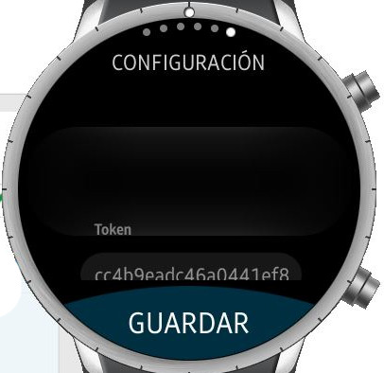 | Introduction of the token and the id of our devices.

